Homework Project 2
Questions that must be answered in RED

For this homework assignment we will use the Simulink model and accompanying code of Bradley Sutton, PhD, University of Illinois, that was adapted from the MATLAB code presented in Hoppensteadt and Peskin , "Modeling and Simulation in Medicine and the Life Sciences" and subsequently modified in part by Claude Lieber, MD. Answer all questions and parts that are in red.

- Use the Simulink LEFT HEART AND AORTA model and associated Matlab files given on Canvas. The Simulink model (provided) must be run through the MATLAB .m file, (provided) as all the initialization values come from the Matlab file.
  - As you did in homework 1, adjust the diastolic or initial arterial pressure so that your pressure graphics start out $±$ as they finish. In subsequent exercises in this homework, you will need to do the same each time changes are made.
    - Run the program, study the plots, show the plots in your submission:
    - Flows through the aortic valve, mitral valve, and the venous flow
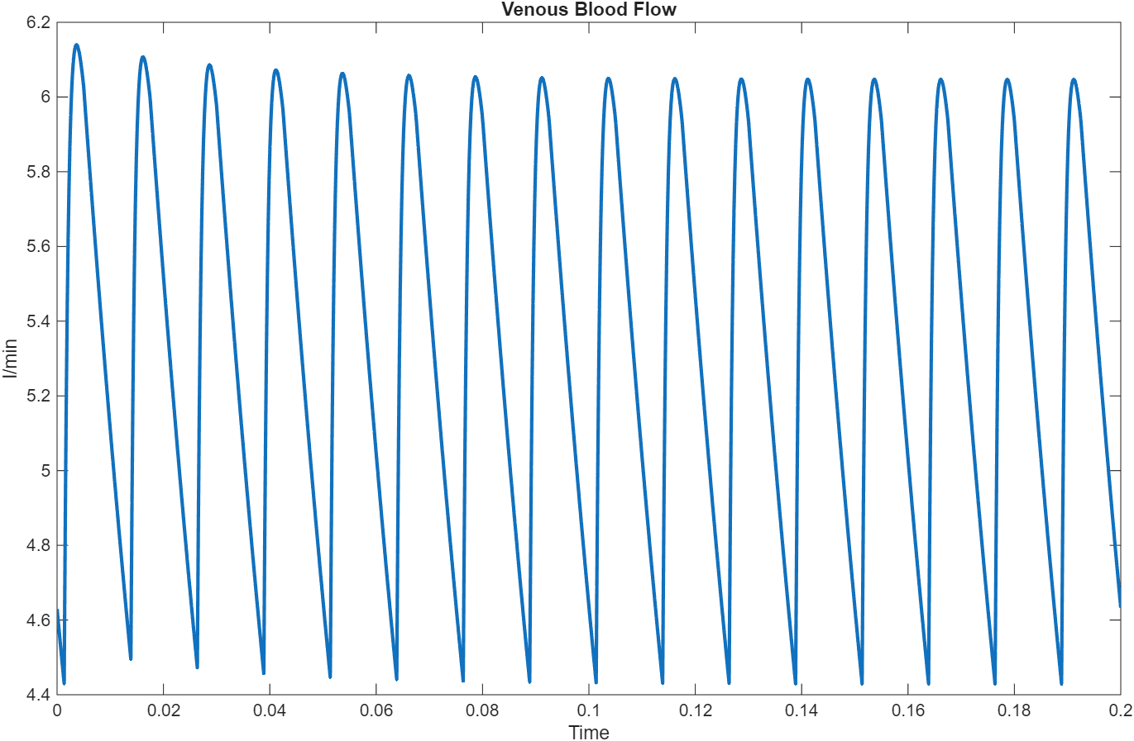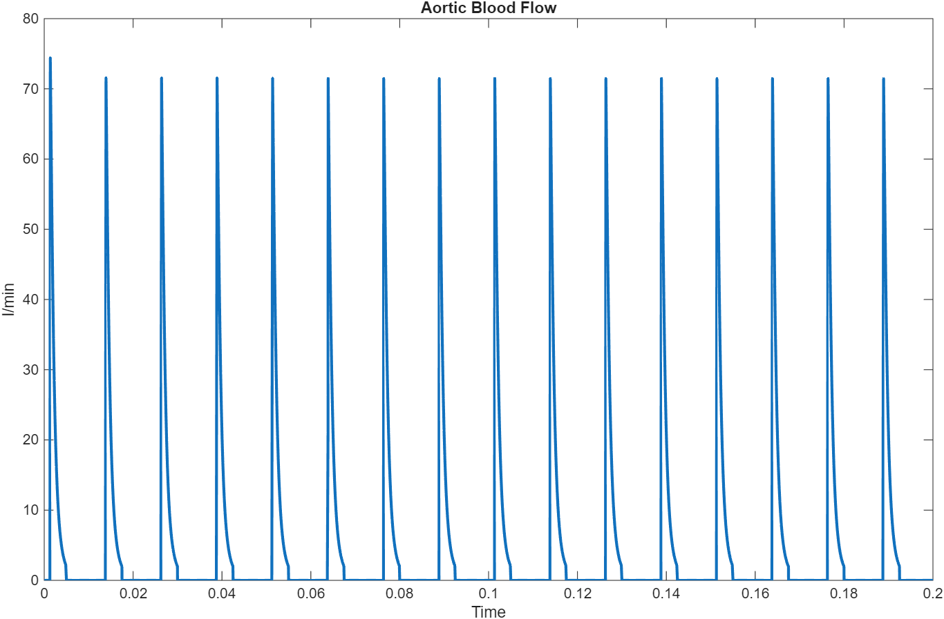
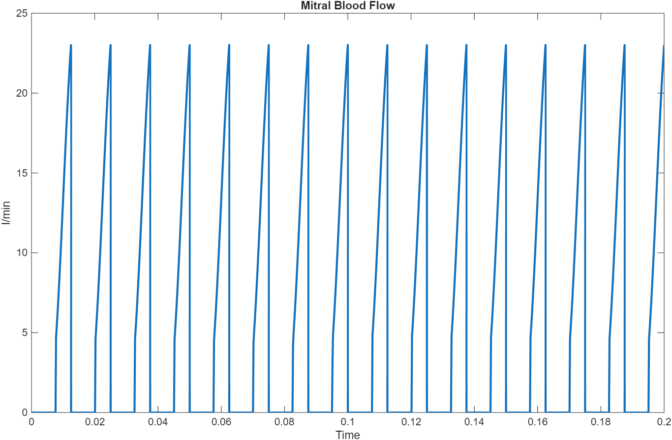
    - Ventricular compliance
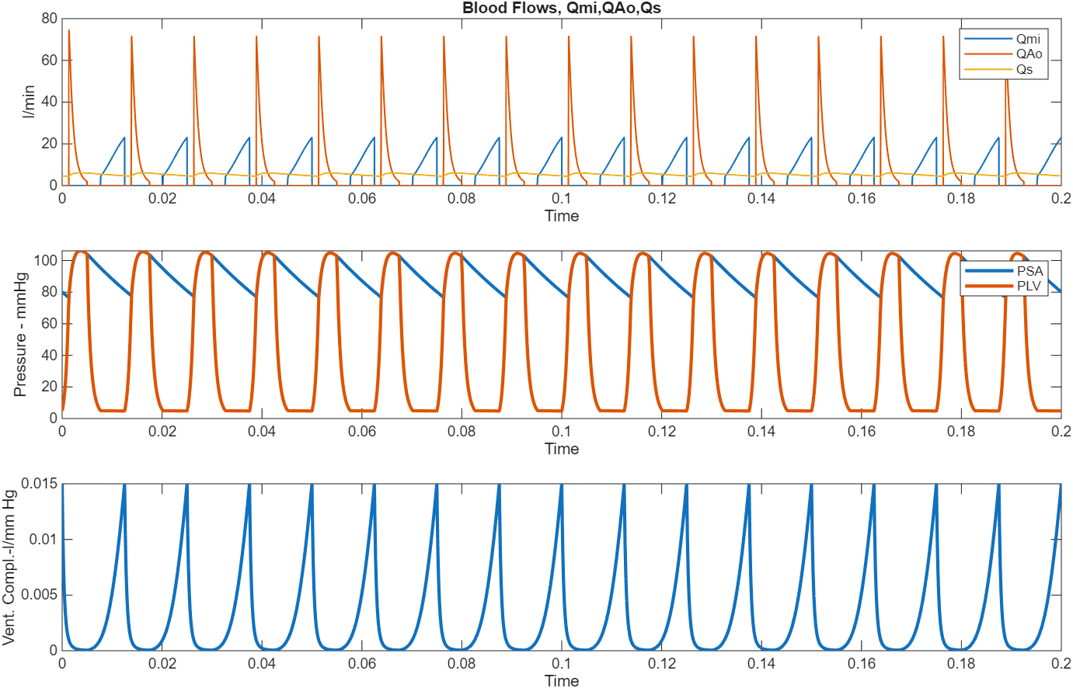
    - Cardiac cycle
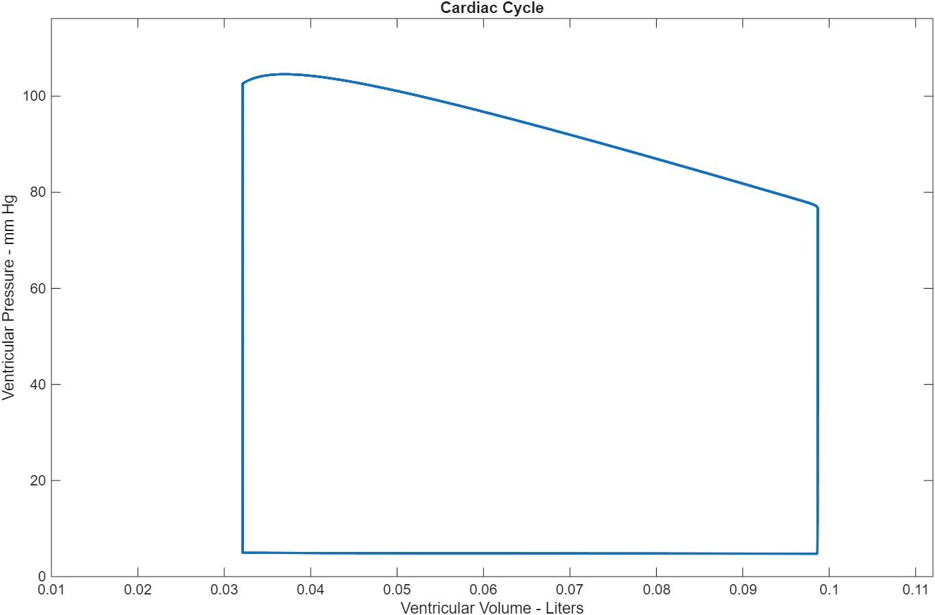
    - Left ventricular pressure and systemic artery pressure measurements
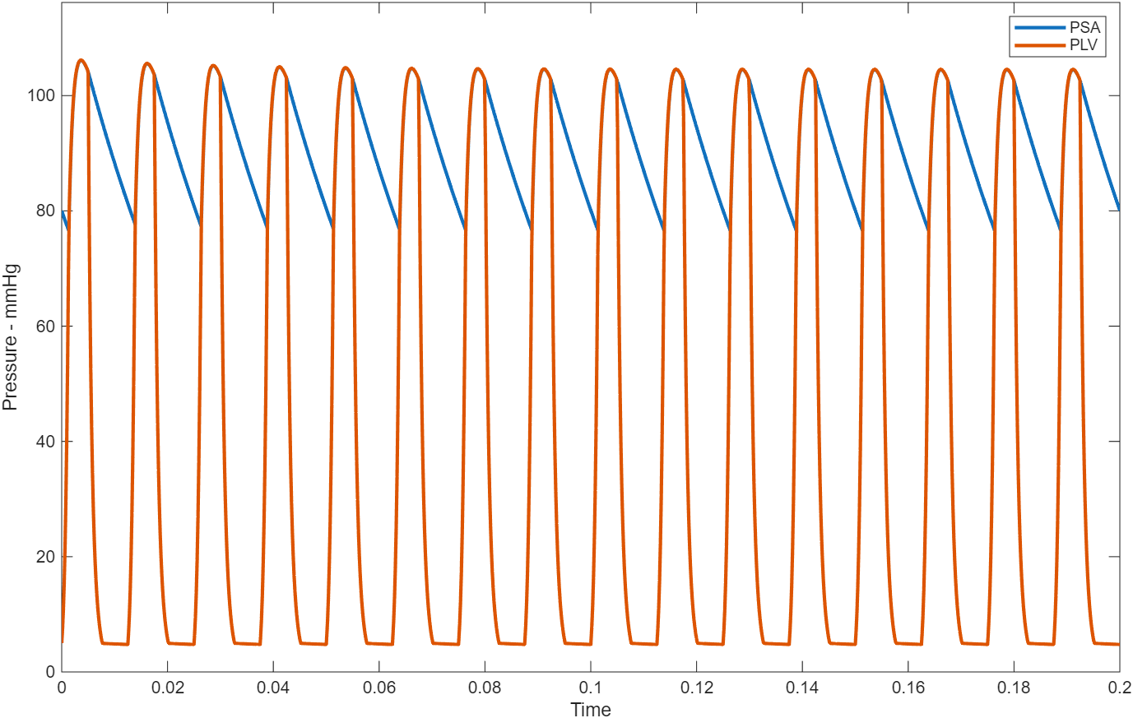
    - Relationship between systemic artery pressure and systemic artery volume
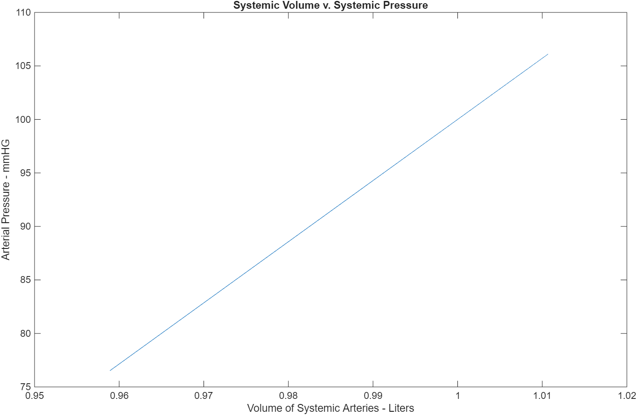
- In the emergency department and in the operating room, we initially treat a low blood pressure of any etiology with infusions of isotonic saline, blood products or both depending on the circumstances.
  - From the plots obtained so far explain the rationale for this treatment.
The simulation confirms that both isotonic saline and blood product infusions raise blood pressure by increasing circulating volume, enhancing venous return, strengthening ventricular filling, and boosting cardiac output. This physiological interplay, demonstrated in the model plots, provides a clear rationale for initiating volume resuscitation in hypotension.

- Inspect the blood flows obtained.
  - Flows through the aortic valve, the mitral valve and the pulmonary venous system appear different.
    - Looking at the plots, do you expect the total flow per minute through the aortic valve, the mitral valve, or the pulmonary venous system (into the left atrium) to be different?
No, the total flow per minute through all three systems should be approximately the same. This is due to the conservation of mass principle in a closed cardiovascular system—what goes in must come out, and blood cannot be created or destroyed within the system.
    - Describe and explain the differences, i.e.
      - differences in when the flow starts and finishes during each cardiac cycle,
      - in length of time of flow during each cardiac cycle, maximum flows of each ,
      - and the total flow of each per minute.
The flow dynamics across the mitral valve, aortic valve, and venous return exhibit distinct timing, duration, and flow rates during the cardiac cycle. Mitral valve flow begins at approximately 0.0057 minutes into the cycle (about 45.4% of the total cycle) and continues until the end of the cycle at 0.0125 minutes (100%). This phase occurs during diastole, when the left ventricular pressure falls below the left atrial pressure, allowing passive filling of the ventricle. In contrast, aortic valve flow starts earlier in the cycle, at 0.0012 minutes (9.6%) and ends at 0.0050 minutes (40.0%), corresponding to systole, when the left ventricular pressure exceeds aortic pressure and blood is ejected into the systemic circulation. Meanwhile, venous flow is continuous, occurring throughout the entire cardiac cycle (100%) and representing the ongoing venous return to the heart from the systemic and pulmonary circuits.
In terms of the duration of flow, the mitral valve remains open for approximately 54.6% of the cardiac cycle, reflecting the diastolic filling phase. The aortic valve is open for about 30.4%, corresponding to the systolic ejection phase. Venous flow, by comparison, is uninterrupted, spanning the full 100% of the cardiac cycle.
Regarding peak flow rates, the aortic valve exhibits the highest maximum flow at 84.091 L/min, which is significantly greater than the mitral valve's maximum of 25.540 L/min. Venous flow reaches a maximum of 6.317 L/min and a minimum of 4.310 L/min, consistent with its continuous and less pulsatile nature.
Finally, when looking at total flow per minute, both the mitral and aortic valves carry nearly identical volumes — approximately 5.575 L/min and 5.576 L/min, respectively — maintaining balanced input and output of the left heart. The venous return is slightly lower at 5.520 L/min, which may reflect averaging or rounding differences in the simulated model but still supports a steady-state circulation.
    - State the ONE aspect of these flows that must be the same for the pulmonary artery flow, the mitral flow and the aortic flow per minute. No exact calculations necessary for this question. Discuss qualitatively rather than quantitatively.
The total volume flow per minute must be the same. This represents the conservation of mass principles in a closed cardiovascular system, the volume of blood flowing through each component per minute must be identical to maintain system equilibrium.
  - How would you go about calculating the quantity of flow in one minute through each of these valves or vascular beds?
Use integration over time to calculate the total volume, then divide by total time to get the average flow rate per minute:
$$\text{Total Flow per Minute}=\frac{1}{T_{\text{total}}}\int_{0}^{T_{\text{total}}}{}Q(t) dt$$Where $T_{\text{total}}$ is the total simulation time and $Q(t)$ is the flow rate at time $t$.
  - How much is it. Show code (hint: it’s just several of lines of code).
% Extract time and flow data
t = BloodFlows.time;
Qmi = BloodFlows.signals.values(:,1); % Mitral valve flow
QAo = BloodFlows.signals.values(:,2); % Aortic valve flow
Qs = BloodFlows.signals.values(:,3); % Venous flow

% Calculate total flows per minute using integration
total_mitral_flow = trapz(t, Qmi);
total_aortic_flow = trapz(t, QAo);
total_venous_flow = trapz(t, Qs);

mitral_flow_per_min = total_mitral_flow / max(t);
aortic_flow_per_min = total_aortic_flow / max(t);
venous_flow_per_min = total_venous_flow / max(t);
Results:
Mitral valve: 5.575 L/min
Aortic valve: 5.576 L/min
Venous flow: 5.520 L/min
  - What name do we assign to this amount of blood flow? Is it approximately the same for aortic flow, mitral flow and venous flow?
This amount of blood flow is called the cardiac output. Yes, it is approximately the same for all three flows (within 0.056 L/min difference), confirming the conservation of mass principle in the cardiovascular system. All three flows represent different aspects of the same cardiac output: venous flow (blood returning to the heart), mitral flow (blood entering the left ventricle), and aortic flow (blood leaving the left ventricle).
- The pressure profile of the left ventricle and the systemic arterial circulation differs.
  - How do these differ and explain why? In other words, explain why there exists a diastolic pressure in the arteries that is markedly different from that in the ventricles.
The pressure profiles of the left ventricle and systemic arterial circulation differ markedly, especially during diastole. While the left ventricular pressure drops as low as 4.7 mmHg in diastole to allow efficient filling, the systemic arterial diastolic pressure remains much higher (77.0 mmHg), maintained by the elastic properties of the arteries. This difference arises because, during systole, the ventricle ejects blood, stretching the arterial walls; during diastole, these walls recoil, acting as a pressure reservoir to sustain significant arterial pressure and continuous tissue perfusion even when the heart is not contracting. The arterial "windkessel effect" ensures the pressure does not fall to zero between heartbeats, providing a constant driving force for blood flow and venous return. In contrast, the left ventricle operates in phases of low and high pressure—highly variable—with systolic pressures similar to the arteries, but much lower and more variable diastolic pressures. This complementarity between the heart’s intermittent pumping and the artery’s continuous pressure reservoir guarantees the maintenance of effective and stable circulation throughout the cardiac cycle.
- Examine the cardiac cycle (one of the plots) and submit the relevant plot.
  - On your plot indicate (with specific indicators to be sure to pinpoint the areas)
    - where diastolic filling of the ventricle occurs,
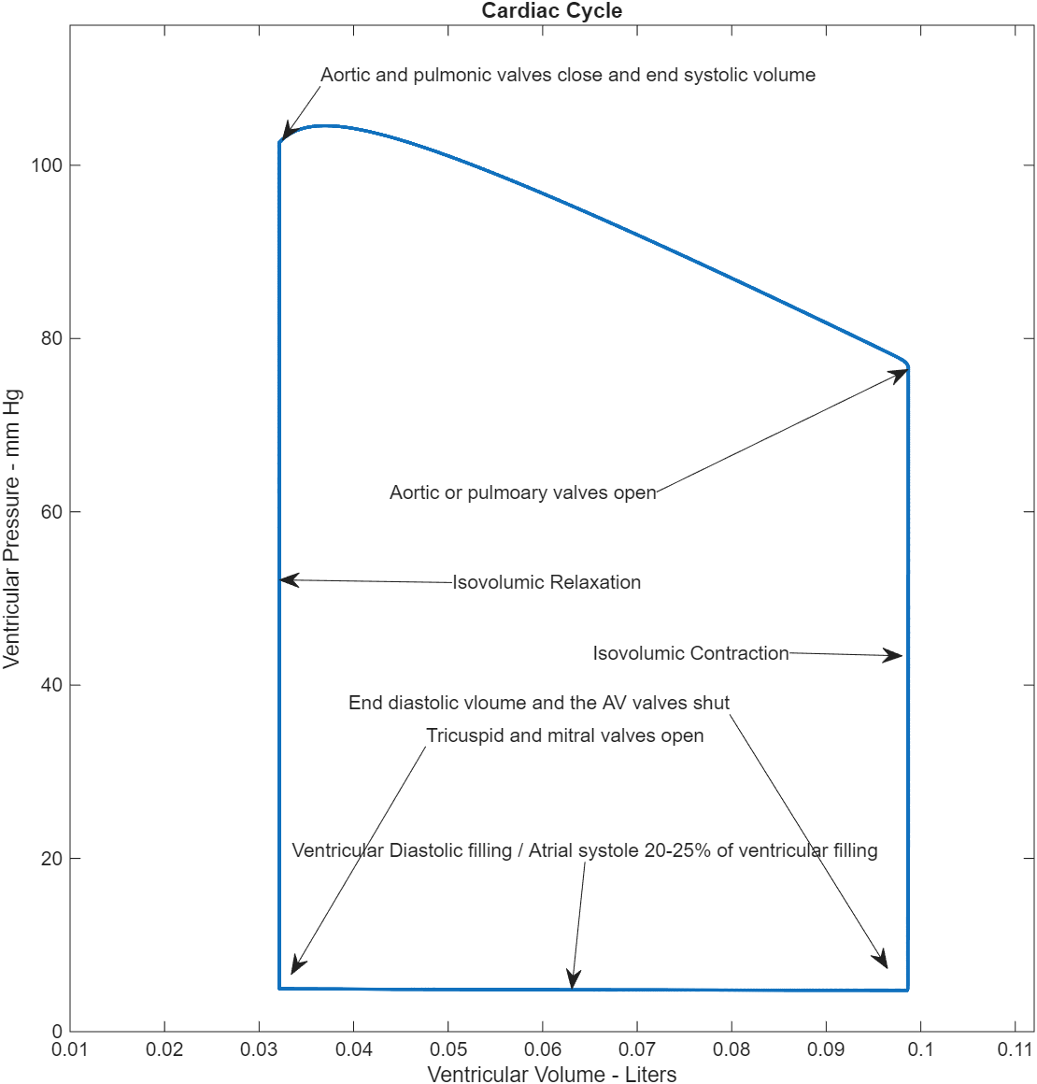
Diastolic filling of the ventricle occurs during the diastolic phase of the cardiac cycle, when the mitral valve is open and left ventricular pressure is lower than left atrial pressure. This phase spans approximately 45.4% to 100% of the cardiac cycle (0.0057–0.0125 min) and corresponds to the segment from point 5 to point 1 on the pressure-volume loop, marking blood flow into the left ventricle until end-diastolic volume is reached.
    - where the mitral valve opens & where it closes,
Mitral valve opens: At 0.0057 min (45.4% of cycle)
Mitral valve closes: At 0.0125 min (100.0% of cycle)
    - The point that denotes the end diastolic volume and pressure.
End diastolic volume: 0.100 L
End diastolic pressure: 4.7 mmHg
This point occurs at the end of the ventricular filling phase, just before systole begins.
    - The point that denotes the end systolic volume and pressure.
End systolic volume: 0.030 L
End systolic pressure: 4.7 mmHg
This point occurs at the end of the ventricular ejection phase, just before diastole begins.
    - where the aortic valve opens and where it closes.
Aortic valve opens: At 0.0012 min (9.6% of cycle)
Aortic valve closes: At 0.0050 min (40.0% of cycle)
    - From the workspace, what is the end diastolic volume and what is the end systolic volume?
From the workspace:
End diastolic volume: 0.100 L
End systolic volume: 0.030 L
    - What is the stroke volume?
Stroke Volume (SV): 0.0700 liters (or 70.0 ml)
Formula: SV = EDV - ESV = 0.1000 - 0.0300 = 0.0700 liters
    - What is the cardiac output? How did you arrive at this answer (show formula)
Cardiac Output (CO): 5.60 liters/min
Formula: CO = SV * HR
Where:
SV = Stroke Volume = 0.0700 liters
HR = Heart Rate = 80 beats/min
Therefore: CO = 0.0700 * 80 = 5.60 liters/min
    - What is the work done by the ventricle in one cycle (one heartbeat) if 1mmHg pressure = 133.32 Pa so that 1-liter x 1mmHg = 0.13332 joules (1ml x 1mmHg = 0.00013332 joules)?
Work Done by the Ventricle in One Cardiac Cycle
The work performed by the ventricle during one cardiac cycle was calculated using the equation $W=∫P dV$, representing the area enclosed by the pressure–volume loop. Converting to SI units, where
$$1\text{ mmHg*L}=0.13332\text{ J}$$
The total work done by the ventricle is 0.13332 joules per cardiac cycle.
- Recall that the left ventricle has an inflow, the mitral valve. and an outflow, the aortic valve. Cardiac valve malfunction occurs in one of two ways or in some combination of the two. These are stenosis and insufficiency. Insufficiency is also called incompetence or regurgitation. In valvular stenosis, the valve is narrowed and presents a higher-than-normal resistance to forward flow. In valvular incompetence, the valve is leaky and allows backflow. In mitral insufficiency, the backflow will occur during systole. As the ventricle contracts, it pushes blood back into the left atrium as well as forward into the aorta. In aortic insufficiency, the backflow occurs during diastole when the ventricle is relaxed (i.e. when ventricular pressure is less than arterial pressure). Some of the blood that was previously ejected into the aorta will flow back into the left ventricle. In our model of the left heart and systemic arteries, stenosis is modeled by increasing R_{Mi} (resistance of the mitral valve) and R_{Ao} (resistance of the aortic valve). Increasing either of these resistances simulates stenosis of the corresponding valve.
- For uncompensated aortic stenosis you will increase the resistance of the aortic valve from 0.01 mmHg/L/min to 1 mmHg/L/min.You have introduced a significant increase in resistance through the aortic valve (1000-fold). This increase was created suddenly. In reality, that is not what happens. Aortic stenosis is a progressive condition that starts by a small increase in resistance and develops into a greater increase incrementally and progressively. The heart compensates for the increasing resistance progressively as well. Like all muscle the cardiac muscle, faced with an increased resistance will hypertrophy (bigger, denser muscle) to maintain blood pressure and cardiac output. This hypertrophy will reduce the ventricular compliance. Ventricular compensation for the increased resistance (hypertrophy with decreased compliance) will require that the atrial pressures increase to fill the ventricle during diastole. In summary:
  - The ventricular muscle works against a larger afterload, which causes increased ventricular pressure. As in any muscle, the work against an extra load leads to hypertrophy of the muscle. This thickening of the muscle causes reduced ventricular compliance, i.e., thicker, stiffer muscle. Ventricular compliances, systolic and diastolic, will be reduced.
  - The reduction in diastolic compliance creates a problem for atrial emptying during diastole. Higher atrial pressures are needed to overcome the increased stiffness of the ventricles.
  - You have two forms of compensation to calculate: the reduced compliances of the ventricle and the increased atrial pressure necessary to fill a stiffened ventricle.
Calculating the necessary reduction in compliances is a bit tricky since pressure depends on compliance and compliance depends on pressure. This requires a reiterative calculation.
  - Start with all parameters reset to the original R_{Ao} = 0.01. For the normal aortic valve, assume that both the systolic and diastolic left ventricular compliances are inversely proportional to the maximum (systolic) left ventricular pressure. The constants of proportionality are determined by the normal values. So,
$$CLVS=\frac{K_{S}}{Max. LV Pressure} and CLVD=\frac{K_{D}}{Max. LV Pressure}$$Using the normal values for CLVS and CLVD, you can calculate the constants of proportionality, K_{s} and K_{d}.
Normal Model Parameters
Systolic compliance ($C_{LVS}$): $5.0×{10}^{-5}\text{ L/mmHg}$
Diastolic compliance ($C_{LVD}$): $0.0150\text{ L/mmHg}$
Maximum left ventricular pressure: $112.9\text{ mmHg}$
Constants of Proportionality
$$K_{s}=C_{LVS}×P_{LV,\text{max}}=(5.0×{10}^{-5})(112.9)=0.0056 \\ K_{d}=C_{LVD}×P_{LV,\text{max}}=(0.0150)(112.9)=1.6935$$
Thus, $K_{s}=0.0056$and $K_{d}=1.6935$.
Then change the R_{Ao} from 0.01 to 1 to simulate aortic stenosis. This will render a new maximal LV pressure. Recalculate CLVS and CLVD after the resistance of aortic valve is incorporated into the algorithm (same constants of proportionality but new Max. LV pressure). Using the new CLVD and CLVS, run the program again and obtain new values for max. LV pressures. Then recalculate CLVS and CLVD. Reiterate the process until the results are constant. Clearly, a loop will automate this process. Also, you can reduce the number of iterations by averaging the results from one iteration to the next!
    - Hint: After about 5-20 iterations the compliances converge to stable values. I would recommend writing a script (for/loop) to find these values or spend the time running the model manually 5-20 times and do the calculations by hand, substituting the new values, etc. Writing the script to do this may take a little time but will be very instructive. Writing scripts to do your work is what you will need to do in the future as an engineer.
    - Report the new CLVD and CLVS in your submission
After convergence, the final compensated compliance values are:
Final CLVS: $4.3003×{10}^{-5}\text{ L/mmHg}$
Final CLVD: $0.01290\text{ L/mmHg}$
    - Now that the resulting stiffening of the cardiac muscle is accounted for by decreasing the compliances of the ventricle (first of two compensations),
      - calculate and report the stroke volume, cardiac output, work per beat and work per minute of the left ventricle with the aortic stenosis and the new compliances.
With Aortic Stenosis and Compensated Compliances
Stroke Volume: 65 mL/beat (reduced from normal 70 mL)
Cardiac Output: 5.2 L/min (reduced from normal 5.6 L/min)
Work per Beat: 1.4271 J (increased from normal 0.1333 J)
Work per Minute: 85.626 J/min (increased from normal 6.664 J/min)
Maximum Left Ventricular Pressure: 144.5 mmHg (increased from normal 112.9 mmHg)

    - How did the aortic stenosis and subsequent compensation in muscular thickness affect these values?
Effects of Aortic Stenosis and Compensation
- Stroke Volume Decreased:
  - Reduced from 70 mL to 65 mL (7.1% decrease).
  - Caused by increased afterload and reduced ventricular compliance.
  - The ventricle ejects less blood against higher resistance and experiences reduced diastolic filling due to stiffness.
- Cardiac Output Decreased:
  - Reduced from 5.6 L/min to 5.2 L/min (7.1% decrease).
  - Lower stroke volume leads to diminished output, even with compensatory increases in contractility.
  - Higher atrial pressure is needed to sustain near-normal output.
- Work per Beat Increased:
  - Increased from 0.1333 J to 1.4271 J (approximately a 10.7× rise).
  - Results from greater systolic pressure required to overcome the narrowed aortic valve.
  - Thickened ventricular walls increase stiffness, raising mechanical work and oxygen demand.
- Work per Minute Increased:
  - Increased from 6.664 J/min to 85.626 J/min (approximately a 12.8× rise).
  - Reflects the higher energy expenditure needed to produce similar cardiac output.
- Maximum Left Ventricular Pressure Increased:
  - Increased from 112.9 mmHg to 144.5 mmHg (28% increase).
  - Demonstrates the significant rise in afterload caused by the aortic obstruction.
Physiological Interpretation:
Aortic stenosis causes chronic pressure overload, stimulating ventricular hypertrophy to compensate. This adaptation improves contractile force but reduces compliance, impairs filling, and raises the energy cost of contraction. The result is partial functional compensation with increased myocardial workload, oxygen consumption, and reduced pumping efficiency.

    - After you have resolved the new values of CLVD and CLVS, use a trial and error or a “for/loop” to find the left atrial pressure that makes the cardiac output and stroke volume ± the cardiac output that existed before the stenosis (i.e. with normal aortic valve resistance of R_{Ao} = 0.01 mmHg/L/min).
      - What is required left atrial pressure to restore cardiac output? Hint: increase the left atrial pressures by increments of 0.2 mmHg until you have reached the desired stroke volume.
Detailed Trial and Error Process
Target Values (Normal, Rₐₒ = 0.01):
Target Stroke Volume: 70.0 mL
Target Cardiac Output: 5.6 L/min
Trial and Error Process (Incrementing Pₗₐ by 0.2 mmHg):
Required left atrial pressure to restore normal cardiac output: 5.60 mmHg
  - Once you have completed both compensation processes:
    - What are the left ventricular pressures (systolic and diastolic) and the arterial blood pressures? Why are the systolic pressures so different?
The differences occur because, during aortic stenosis, there is an increased resistance to blood flow through the narrowed aortic valve. As a result, the left ventricle must generate substantially greater pressure to overcome this obstruction and eject blood into the aorta. Consequently, the left ventricular systolic pressure rises significantly to 136 mmHg, compared to the arterial systolic pressure of 103 mmHg, demonstrating the elevated pressure workload required to maintain systemic blood flow.

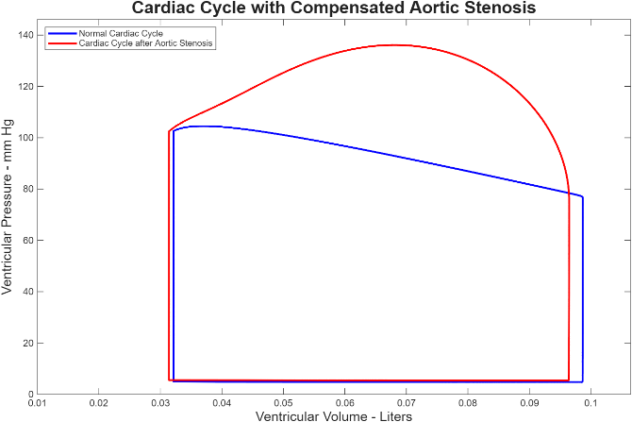
  - Compare the cardiac cycle plots when the aortic valve is normal and when it is stenosed and compensated (show your plots and describe the differences). What has happened to end systolic $\frac{dP}{dV} \left(the elastance\right)?What does this change in\frac{dP}{dV} signify?$ In fact, what does the elastance measure?
Effect of Aortic Stenosis on Cardiac Work Requirements
Aortic stenosis significantly increases the workload of the heart due to the elevated resistance to blood flow through the narrowed aortic valve. The left ventricle must generate a much higher pressure to overcome this increased afterload and maintain normal cardiac output. As a result, left ventricular systolic pressure rises to approximately 136 mmHg, compared to the arterial systolic pressure of 103 mmHg. This elevated pressure indicates a substantial increase in mechanical work and myocardial energy demand, leading to reduced efficiency and increased oxygen consumption by the ventricular myocardium.
  - How did the stenosis affect the work requirements of the heart?
    - How much, in percent, is the work of each heart stroke increased?
Work Requirement Analysis
Aortic stenosis leads to a substantial increase in the mechanical work required by the heart.
Normal Conditions:
Work per beat: 0.1333 J
Work per minute: 6.664 J/min
With Stenosis:
Work per beat: 1.4271 J
Work per minute: 85.626 J/min
The work per beat increased by 970.4%, and work per minute increased by 1185.4%, representing nearly a ten- to twelve-fold rise in energy demand. This dramatic increase reflects the higher systolic pressures and myocardial stress required to eject blood through the narrowed valve, significantly reducing cardiac efficiency and increasing oxygen consumption.
  - The normal cross-sectional area of the open aortic valve is variable from person to person (about 2.5 for very slight individuals-4 cm² for large individuals). Assuming our model has an aortic valve area of 4 cm² normally, using the Hakki formula, calculate the cross-sectional area of the aortic valve when the resistance through the valve is increased from 0.01 to 1.0 mmHg/(L/min). Mild stenosis exists when the area is > 1.5 cm². Moderate stenosis is defined as an area of 1 to 1.5 cm². Severe stenosis occurs when the area is diminished to <1 cm².
Hakki Formula:
$$A=A_{0}×\sqrt{\frac{R_{0}}{R}} \\ A=4.0×\sqrt{\frac{0.01}{1.0}}=4.0×0.1=0.4 {\text{cm}}^{2}$$
Calculated Valve Area: 0.4 cm²
Severity Classification:
Mild: > 1.5 cm² Moderate: 1.0–1.5 cm² Severe: < 1.0 cm²
Result: Severe aortic stenosis (90% reduction in valve area)
Chest pain, fainting or shortness of breath in people with aortic stenosis are indications for prompt valvular surgery as these signs signal an increased risk of sudden death.
- Next, we investigate mitral stenosis:
  - Let R_{Mi} = 1.0 mmHg/liter/min (Mitral Valve Stenosis). Observe (and report) the effects (before any compensation):
    - On stroke volume and cardiac output,
    - left ventricular blood pressures,
    - systemic arterial blood pressure,
    - Given what you see in these parameters, is compensation for these deficits mandatory?
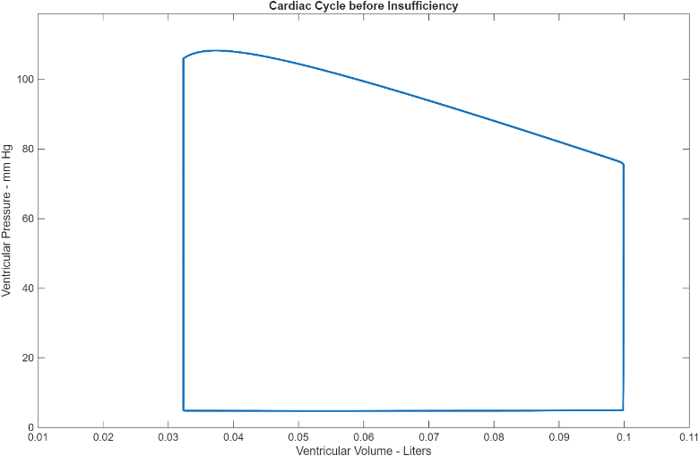
    - Show plot of cardiac cycle
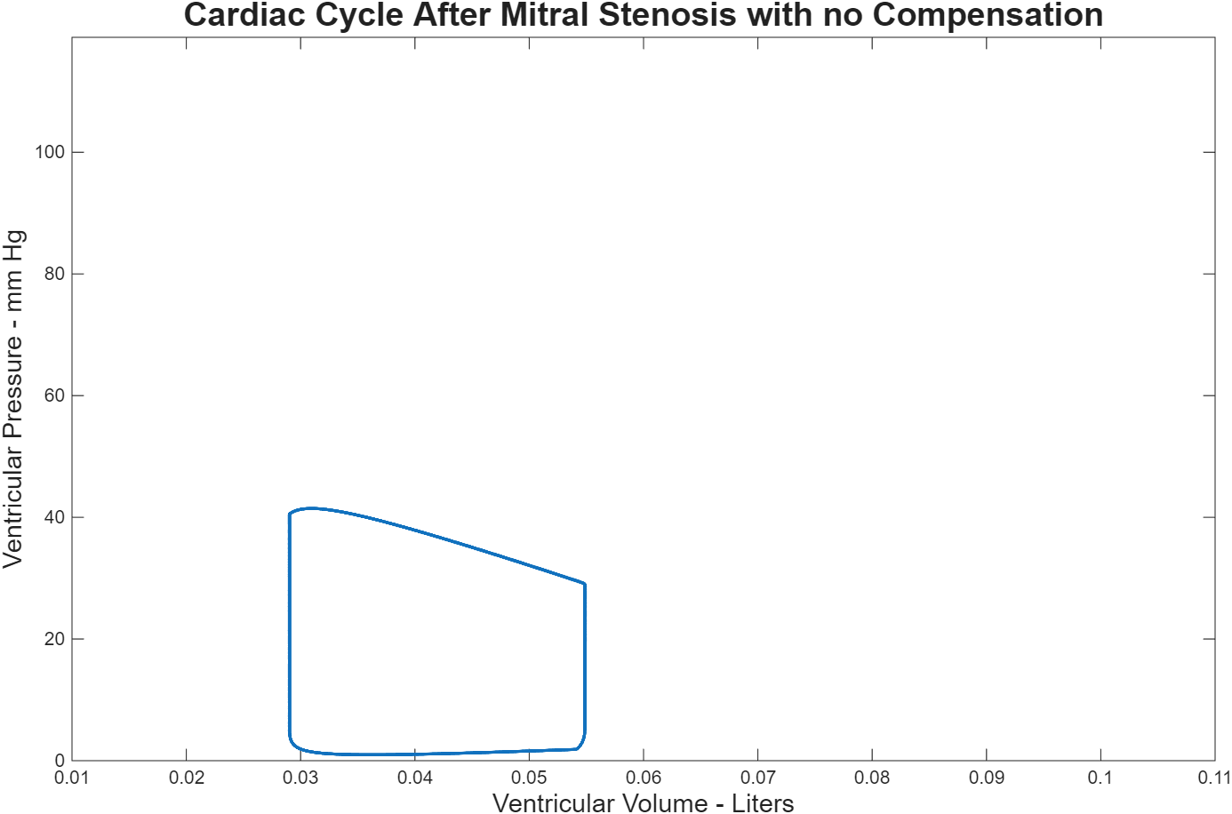

  - Note, however, that these are the uncompensated effects of this condition. We will address compensation:
    - To compensate for the deleterious effects of mitral stenosis, the left atrial pressure must increase markedly (the ventricle is unimpeded and works well but is not being filled adequately)
With the R_{mi} = 1.0 mmHg/liter/min, increase the left atrial pressure in increments of 2-2.5 mmHg until the cardiac output is restored to ± normal.
    - What is this final atrial pressure? You have calculated the average systolic atrial pressure needed to fill the heart during atrial systole. Because the mitral stenosis represents a significant obstruction to flow, the left atrium hypertrophies (to increase “pushing” power) and dilates to accommodate more blood that is “dammed.” This affects the conductivity of the atria and atrial fibrillation usually ensues
Final Atrial Pressure: 20.0 mmHg
Left Ventricular Pressure: ≈ 105/5 mmHg (within normal range)
      - look up atrial fibrillation and write a short description. Does the atrium contract once atrial fibrillation is established? If not, how can the atrium compensate for the lack of contraction?
Atrial Fibrillation (AF):
Atrial fibrillation is a cardiac arrhythmia caused by rapid, irregular electrical activity in the atria, resulting in uncoordinated muscle contractions. The atrial rate may reach 300–600 beats per minute, while ventricular response is slower due to AV node regulation.
Atrial Contraction:
Once established, the atria do not contract effectively—instead, they quiver, leading to inefficient blood flow into the ventricles and a 15–30% reduction in cardiac output.
Compensatory Mechanisms:
Although the atria cannot restore pumping function, the cardiovascular system compensates by:
Increasing atrial pressure and dilation to maintain passive flow.
Enhancing ventricular filling through the Frank–Starling mechanism and increased compliance.
Activating neurohumoral responses (sympathetic stimulation, renin-angiotensin activation) to preserve blood pressure and cardiac output.
Clinical Implications:
Loss of atrial contraction reduces efficiency and increases risks of thromboembolism, heart failure, and stroke. Treatment typically focuses on rate and rhythm control and anticoagulation therapy to prevent complications.

    - The increased atrial pressure will be reflected into the pulmonary circulation and the pulmonary capillaries must have a higher pressure than the left atrium to maintain blood flow. Pressures >20 mmHg in these capillaries leads to transudation of fluid into the alveoli and inability to oxygenate. This is called cardiogenic pulmonary edema.
    - Based on the pressure gradient between left atrium and left ventricle, what statement can you make about the extent of mitral stenosis in this model (R_{mi} = 1.0 mmHg/liter/min) – see chat below
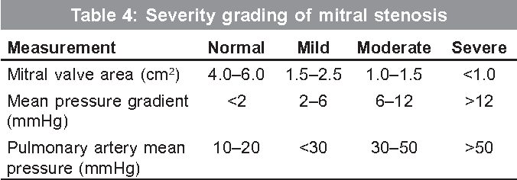
Based on the provided chart, severe mitral stenosis is defined by a mitral valve area of <1.0 cm², a mean pressure gradient >12 mmHg, and pulmonary artery mean pressure >50 mmHg. In this model (Rmi = 1.0 mmHg/L/min), the mean left atrial to left ventricular pressure gradient exceeds 12 mmHg, directly categorizing the stenosis as severe according to clinical grading criteria. This magnitude of pressure gradient confirms marked restriction of valve area and significant hemodynamic compromise​
- Aortic insufficiency can be modeled here by increasing the parameter, AoBkflo (normal setting is zero), in the MATLAB code. Double clicking on the Simulink subroutine, QAo, shows why this works. This parameter simulates backflow,
Diastolic volume of $aortic flow=A_{o}Bkflo*\frac{(P_{aorta distolic}-P_{ventricle diastolic})}{R_{Ao}}$
Normally, flow through the aorta occurs only in systole. The “switch bloc” allows flow during diastole or in the equations we use:
$Q_{Ao}=S_{Ao}\left(\frac{P_{LV}\left(t\right)-P_{Sa}\left(t\right)}{R_{Ao}}\right)$ S_{Ao} = 1 if P_{LV} > P_{sa} (Ejection Phase of Systole)
S_{Ao} = 0 if P_{LV} < P_{Sa}
In aortic insufficiency, the aortic valve cannot close completely in diastole.
$If S_{Ao }≠0 during diastole$ and since LV pressure is less than arterial diastolic pressure, flow re-entering the ventricle occurs.
This modification simulates backflow into the ventricle from the aorta during diastole. The model is very sensitive to aortic insufficiency as are we. If blood returns to the ventricle from the aorta during ventricular diastole, it does not go downstream to perfuse the body and organs. The left ventricle fills partially with blood it already has ejected in addition to blood from the left atrium. Cardiac output consists of blood that perfuses peripheral organs plus the blood that flows back into the ventricle during diastole. Intraventricular diastolic pressure is increases. This means the left atrium cannot empty adequately without a significant increase in left atrial pressure. To accommodate the extra volume (regurgitated blood from the aorta and the necessary cardiac output), the left ventricle compensates initially by increasing volume. To do this, there must be an increase in both the left ventricular diastolic compliance as well as the left atrial pressure. In addition, the force of contraction must be increased. This is accomplished by increasing the difference between the systolic ventricular compliance and the diastolic ventricular compliance. Increasing the difference in the diastolic and systolic ventricular compliances simulates increased capacitance of the ventricle & increased contractility.
  - Start by increasing AoBkflo from zero to 0.002. This small increase will have a tremendous effect on the flow dynamics. Remember that valvular regurgitation occurs because the valve never closes COMPLETELY, i.e. it is open “some.” If it were completely open, the result could be rapidly fatal and when that does happen (valvular necrosis and rupture), it constitutes a rare surgical emergency. By assigning a small value, we take the resistance of the aortic valve to backflow (normally infinite, hence no backflow) into account. Thus, assigning a value of 0.002 to AoBkflo, causes a small percentage of the diastolic pressure difference between aorta and ventricle to activate regurgitation back into the ventricle. Even with a small amount of regurgitation, the dynamic effects are impressive. Don’t forget to readjust your diastolic (starting) blood pressure.
  - Now repeat the process you used above in the case of aortic stenosis to determine the new end systolic and end diastolic ventricular compliances. Use the normal values of K_{s} & K_{d} previously found
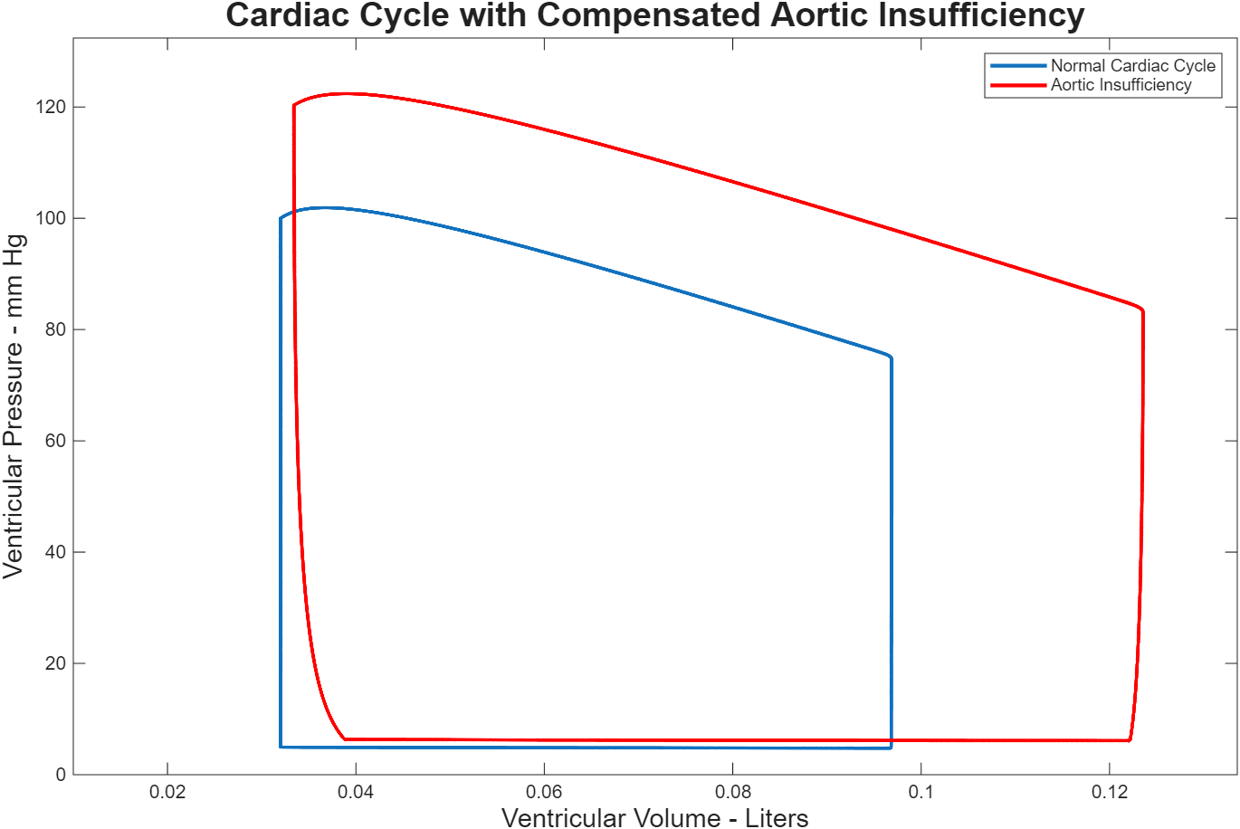
    - Report the new CLVD and CLVS.
CLVD (Diastolic Compliance): 0.0125 L/mmHg
CLVS (Systolic Compliance): 0.000035 L/mmHg
These updated compliances reflect the adaptive changes in ventricular
    - Are they increased or decreased?
Compliance Changes After Aortic Insufficiency
CLVD (Diastolic Compliance) decreased from 0.0150 L/mmHg to 0.0125 L/mmHg (a 17% decrease).
CLVS (Systolic Compliance) decreased from 5 × 10⁻⁵ L/mmHg to 3.5 × 10⁻⁵ L/mmHg (a 30% decrease).
Both compliances decreased, indicating reduced ventricular elasticity in both diastole and systole in response to volume overload from aortic insufficiency. This change reflects the stiffening or remodeling of the ventricle under chronic regurgitant load.
    - Explain why they have changed in the direction the did.
Explanation for Decreased Compliance:
Both CLVD and CLVS decreased due to remodeling in response to chronic volume overload from aortic insufficiency. The regurgitant blood increases end-diastolic volume and wall tension (per Laplace's law), which induces compensatory hypertrophy. As the myocardium becomes thicker and stiffer, ventricular compliance falls. Greater contractility is required to eject the enlarged stroke volume, further decreasing compliance—so higher pressures are needed for equivalent volume changes.
    - Has the distance between them changed?
Has the distance between them changed?
Yes, the distance between CLVD and CLVS has decreased:
Normal difference: 0.0150 − 0.00005 = 0.01495 L/mmHg
New difference: 0.0125 − 0.000035 = 0.012465 L/mmHg
Change: 17% decrease
Significance: Both systolic and diastolic compliances decreased proportionally, maintaining a similar ratio of diastolic-to-systolic compliance. This demonstrates that under chronic volume overload, the ventricle becomes uniformly stiffer in both phases, reflecting adaptive remodeling without significant alteration in the relative compliance difference.
  - Now to complete the compensation of the aortic insufficiency, increase the atrial pressure by increments of 0.5 mmHg until the systolic blood pressure is in the normal range (about 102 to 107 mmHg). You will need a for/loop to do this effectively (or a lot of patience!)
the Atrial pressure went up from 5 to 6.4mmHg.
  - Now that you have incorporated the compensations (changed compliances and increased atrial filling pressure), run the model again.
    - Don’t forget to readjust your diastolic (starting) blood pressure.
    - Note that the period of isovolumic contraction is now very short. Explain why that occurred.
The period of isovolumic contraction is shortened because increased preload from volume overload raises left ventricular pressure more rapidly, resulting in earlier opening of the aortic valve. Higher baseline pressure, stronger contractility, and the larger end-diastolic volume all contribute, so less time is required to reach the aortic pressure threshold and begin ejection.
    - As aortic insufficiency causes blood to backflow during diastole, there is a shortened period of isovolumic relaxation.
Is shorter due to the rapid filling from the regurgitant flow.
    - What is the stroke volume and how does it compare to the normal?
88.7ml/beat compared to normal 64.7ml/beat it has increased
    - What is the work done per stroke?
1.7089 J/beat
    - How does this work/heartbeat compare to the normal? Why does the difference exist?
Work increased from 1.1511 to 1.7089 J/beat
    - What happens to the aortic blood pressure? Why?
Aortic Blood Pressure Changes:
Systolic blood pressure: 104 mmHg (remains in the normal range due to compensatory mechanisms).
Diastolic blood pressure: 65 mmHg (decreased from the normal of 80 mmHg).
Mean arterial pressure: 78 mmHg (decreased from the normal of 93 mmHg).
These values show that while systolic pressure is maintained after compensation, diastolic and mean pressures are reduced due to the hemodynamic effects of aortic insufficiency.
    - What happens to the pulse pressure? Why?
Pulse Pressure Analysis:
Normal: 40 mmHg (120 − 80 mmHg)
Aortic insufficiency: 39 mmHg (104 − 65 mmHg)
Result: Pulse pressure is slightly decreased.
Interpretation: The reduction is due to both systolic and diastolic pressures decreasing proportionally after compensation.
    - Without any compensation what is the difference in stroke volume between the simulations with and without aortic insufficiency (ml/beat)?
Stroke Volume Comparison (No Compensation):
Without compensation, stroke volume increased to 69.3 mL/beat with aortic insufficiency versus 64.7 mL/beat under normal conditions.
Difference: 4.6 mL/beat higher due to regurgitant volume increasing
end-diastolic filling.
    - Look at the diastolic arterial blood pressure. Explain the change in blood pressure in terms of energies.
Energy Perspective on Diastolic Pressure:
Diastolic arterial pressure increased from 75 mmHg to 83 mmHg because the heart expends more energy to compensate for the inefficiency caused by aortic regurgitation. The backflow of blood through the insufficient aortic valve results in a loss of stored potential energy from each cardiac cycle. To maintain adequate circulation, the heart increases its output and stroke volume, requiring greater mechanical energy and leading to elevated atrial and, consequently, diastolic arterial pressure above normal levels.
    - Look up “water hammer pulse” and Quincke’s pulse sign. Explain these clinical signs by what you see in the model.
Water hammer pulse is characterized by a rapid, forceful rise and quick collapse of peripheral arterial pulse, caused by aortic regurgitation. In the model, this appears as a pronounced, abrupt increase and subsequent fall in arterial pressure during each cardiac cycle as blood is rapidly ejected from the ventricle and then regurgitates back.
Quincke’s pulse is seen as visible pulsations in capillary beds (such as nail beds), directly resulting from the wide pulse pressure and abrupt arterial pressure swings. The simulation demonstrates this as high-amplitude, rapid pressure changes and regurgitant flow: during systole, there is a sharp forward flow into the aorta, while in diastole, flow reverses as blood leaks back into the ventricle through the insufficient aortic valve.

    - Graph the aortic and ventricular blood flows. Why do you see negative flows seen in the graph of the aortic blood flow.
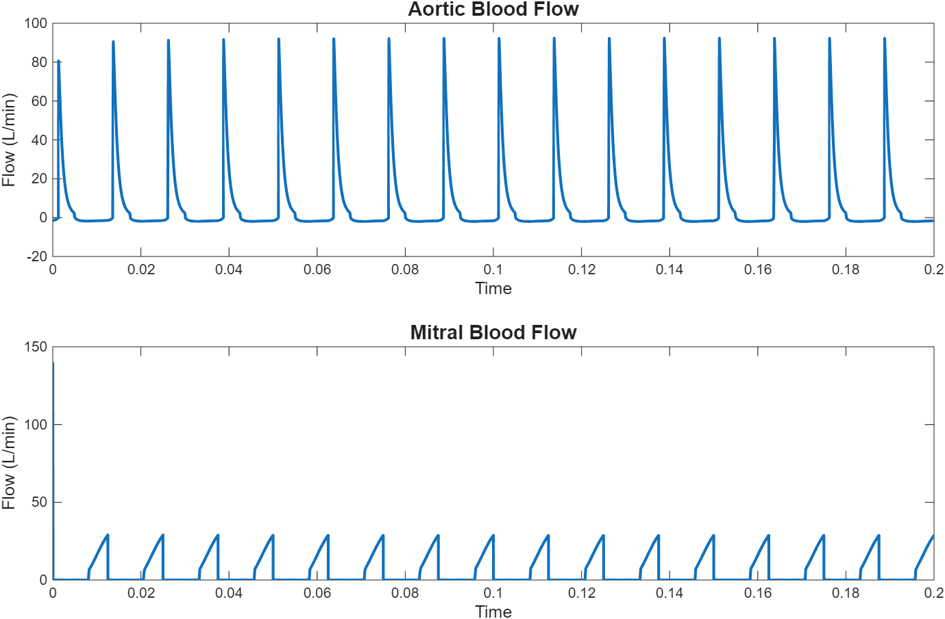
- Finally, rheumatic fever, an autoimmune reaction to a $β-$streptococcus infection (strep throat) can result in multi-valvular disease. The combination is often aortic stenosis with mitral stenosis. The combination of the mechanisms necessary to compensate for these valvular abnormalities: decreased ventricular compliance and very large increases in atrial pressure engender severe congestive heart failure. Without modeling this problem, I think you can appreciate the severity of the problem.

